Tab 1

Network Optimization for

OptiFlow Freight Solutions

A Two-Phase Analysis of Shortest Path and Minimum-Cost Routing for Tesla Semi Trucks (San Francisco to New York)

Course: MSBC 5680 - Optimization Modeling
Instructor: Sentao Miao
Leeds School of Business - University of Colorado Boulder, Fall 2025

- Prepared by Vishwajit Mohan Kumar
Fidelis Mahila Ambrose Lnu,
Ima Mary Mervin,
& Samyuktha Sampath

Table of Contents

1. Introduction ……………………………………………………………………………………………...3

2. Statement of Problem………………….…………………………………………………………………3

2.1 Phase 1 Objective: Distance Minimization..…………………………………………………………3

2.2 Phase 2 Objective: Cost & Operational Minimization.………………………………………………4

3. Summary of Key Findings (Phase 1 & Phase 2) ………………………………………………………...4

4. Methodology and Model ………………………………………………………………………………...5

4.1 Methodology Overview ……………………………………………………………………………..5

4.2 Decision Variables …………………………………………………………………………………..5

4.2.1 Phase 1 Variables ……………………………………………………………………………….5

4.2.2 Phase 2 Variables ……………………………………………………………………………….5

4.3 Objective Functions …………………………………………………………………………………6

4.3.1 Phase 1: Distance Objective …………………………………………………………………….6

4.3.2 Phase 2: Cost Objective ………………………………………………………………………...6

4.4 Constraints …………………………………………………………………………………………..6

4.4.1 Phase 1 Flow Constraints ……………………………………………………………………….6

4.4.2 Phase 2 Operational Constraints ………………………………………………………………..7

5. Data Collection & Description ………………………………………………………………………

5.1 Network Node Selection …………………………………………………………………………

5.2 Mockaroo Dataset Construction ……………………………………………………………………..8

5.3 Distance Estimation & Validation …………………………………………………………………..8

5.4 Variable Definitions and Calculations ……………………………………………………………….9

5.4.1 Distance.…………………………………………………………………………………………9

5.4.2 Energy Rates.……………………………………………………………………………………9

5.4.2 Energy Dollars…………………………………………………………………………………..9

5.4.3 Labor Costs ……………………………………………………………………………………..9

5.4.4 Toll Fees ………………………………………………………………………………………...9

5.4.5 Charge Fees.……………………………………………………………………………………..9

5.4.6 Total Cost.……………………………………………………………………………………….9

6. Numerical Experiment Results ………………………………………………………………………….9

6.1 Optimal Solution & Minimum Cost…….…………………………………………………………..11

6.2 Optimal Path Sequence.....………………………………………..………………………………...11

7. Detailed Path Analysis & Insights.…………………………………………………………………….12

7.1 Path Composition……………..…………………………………………………………………….12

7.1.1 Spatial Layout………………………………………………………………………………….12

7.1.2 Visual Styling.………………………………………………………………………………….12

7.1.3 Constraint Details………………………………………………………………………………12

7.2 Optimal Solution Summary...……………………………………………………………………….13

8. Recommendations, Conclusions & Future Work ………………………………………………………13

9. Appendix..………………………………………………………………………………………………14

9.1 Mock Data Table……………………………………………………………………………………14

9.2 Driving Time Per Driver …………………………………………………………………………...15

9.3 Cost Incurred Per Driver……………………………………………………………………………16

9.4 Key Insights ……………………………………………………………………………………..…17

9.5 Combined Insights……………………………………………………………………………….…17

1. Introduction
We analyze the optimization of the long-haul freight route between San Francisco (SF) and New York (NY) for OptiFlow Freight Solutions, utilizing Tesla Semi trucks. This work is structured into two sequential phases: first, minimizing distance to establish a baseline path, and second, minimizing total cost under realistic operational constraints.
Phase 1: establishes a baseline by identifying the shortest-distance route between San Francisco (SF) and New York (NY) using a network of major U.S. cities, including San Francisco, Salt Lake City, Las Vegas, Denver, Albuquerque, Kansas City, St. Louis, Cleveland, Pittsburgh, and New York. These cities form the nodes of a network, with their inter-city distances defining the arc lengths. The routes chosen by considering only the routes that had EV charging stations. The goal of this phase is to determine the most direct route without considering any cost-related constraints.
Phase 2: extends the analysis by incorporating realistic operational features into the model. These include fixed travel costs, labor costs determined by driver team and wage rates, speed limitations based on truck performance, familiarity-based speed bonuses, and strict limits on driver working hours. Additionally, the full trip must be completed within an 80-hour window. Under this expanded framework, the objective shifts from minimizing distance to minimizing total operating cost, which accounts for both fixed and labor components. Together, these two phases allow for a comparison between idealized and operationally feasible routing strategies.

2. Statement of Problem
The primary goal of this project is to determine the optimal route and driver team assignment for OptiFlow Freight Solutions’ Tesla Semi traveling from San Francisco to New York, first under distance minimization and then under realistic operational constraints.
2.1 Phase 1: addresses the classical shortest-path problem. Using the distances between cities as arc costs, the model selects the path with the minimum total mileage while satisfying standard network flow constraints: the route must start at SF with one unit of outbound flow, end at NY with one unit of inbound flow, and preserve flow conservation at all intermediate cities. This ensures that the solution forms one continuous and feasible cross-country route.
2.2 Phase 2: builds on this foundation by incorporating operational cost drivers such as fixed inter-city travel costs, driver wages, segment travel time, familiarity bonuses affecting speed, and the 60 mph maximum truck speed. Additional feasibility constraints enforce professional and amateur driver hour limits, overall trip time restrictions, and network flow consistency. The optimization objective becomes minimizing total operating cost, defined as the sum of all fixed and labor costs associated with the selected route. This expanded model identifies the cost-optimal combination of route segments and driver assignments while ensuring compliance with all regulatory and operational constraints.

3. Summary of Key Findings (Phase 1 & Phase 2)
The shortest path identified in Phase 1 serves as the structural foundation for the Phase 2 optimization, where the objective shifts to determining the true minimum-cost solution. This extended model incorporates realistic operational constraints, including labor costs, fixed route expenses, and electricity charging costs which vary by state. Driver familiarity plays an important role, compelling the optimizer to strategically allocate the optimal team to each segment to minimize total travel time and cost. This structure, while synthetically created for the model, assigns Team A speed bonuses (driving 10% faster than the capped limit) on western segments (such as Salt Lake City → Denver or Las Vegas → Albuquerque), and Team B speed bonuses on eastern segments (including Kansas City → Cleveland or Cleveland →New York). Additional feasibility constraints further shape the solution space: professional drivers may only work up to 33.33 hours, while amateurs are limited to 46.67 hours; the truck's total driving time cannot exceed 66.67 hours; and the entire trip must be completed within an 80-hour window. Together, these time and resource limitations dictate which driver teams can feasibly operate each segment and ultimately influence the combination of assignments that yields the lowest overall cost.
4. Methodology and Model
4.1 Overview : This project uses a network optimization framework to determine an optimal route from San Francisco to New York. The analysis is separated into two phases. Phase 1 identifies the shortest possible route based solely on distance. Phase 2 expands the model by incorporating fixed route costs, labor costs, effective speeds, driver hour limitations, and overall trip feasibility constraints. Both phases use the same network of cities and the optimization is implemented in Gurobi.

4.2 Decision Variables

4.2.1 Phase 1 uses a single binary decision variable to represent whether each route segment is selected in the shortest path.
Route selection variable:
X(i,j) = 1 if arc (i,j) is selected
X(i,j) = 0 otherwise

4.2.2 Phase 2 includes the same routing variable as Phase 1, along with several additional variables required to incorporate operational constraints.
1. Route selection variable:
X(i,j) = 1 if arc (i,j) is selected
X(i,j) = 0 otherwise
2. Driver team assignment: Team(i,j) ∈ {A, B}
3. Driver type (experience level): Type(i,j) ∈ {Professional, Amateur}
4. Effective speed on each segment: EffSpeed(i,j) = min( BaseSpeed × Bonus , 60 )
5. Familiarity bonus:
Bonus(i,j) = 1.1 if the team is familiar with arc (i,j)
Bonus(i,j) = 1.0 otherwise
6. Labor hours per segment: LaborHours(i,j) = Distance(i,j) / EffSpeed(i,j)
7. Labor cost per segment: LaborCost(i,j) = LaborHours(i,j) × Wage
8. Total driving time: TotalDrivingTime = Σ [ LaborHours(i,j) × X(i,j) ]

4.3 Objective Functions

4.3.1 Phase 1 Objective: Minimize Total Distance
Minimize: Σ [ Distance(i,j) × X(i,j) ]

4.3.2 Phase 2 Objective: Minimize Total Cost
Minimize: Σ [ (FixedCost(i,j) + LaborCost(i,j)) × X(i,j) ]
where LaborCost(i,j) = (Distance(i,j) / EffSpeed(i,j)) × Wage

4.4 Constraints

4.4.1 Phase 1 Constraints (Shortest Path)
Flow conservation ensures the solution forms a single continuous path from the origin (San Francisco) to the destination (New York).
Origin (San Francisco): Σ X(SF,j) − Σ X(i,SF) = 1
Destination (New York): Σ X(i,NY) − Σ X(NY,j) = 1
Intermediate cities k: Σ X(i,k) − Σ X(k,j) = 0

4.4.2 Phase 2 Constraints (Cost Optimization)
Phase 2 includes all Phase 1 constraints and adds additional operational rules.
A. Trip time and driving limitations:
TotalDrivingTime ≤ 80 hours
TotalDrivingTime ≤ 66.67 truck driving hours
Σ LaborHours(i,j) × X(i,j) ≤ 33.33 (Professional drivers)
Σ LaborHours(i,j) × X(i,j) ≤ 46.67 (Amateur drivers)
B. Speed constraint: EffSpeed(i,j) ≤ 60 mph
C. Energy constraint: TotalDistance ≤ 5000 miles
D. Flow constraints (same as Phase 1):
Σ X(SF,j) − Σ X(i,SF) = 1
Σ X(i,NY) − Σ X(NY,j) = 1
Σ X(i,k) − Σ X(k,j) = 0

5. Data Collection & Description
The data for this optimization model was synthesized to create a realistic but controlled, transportation network scenario. The primary data generation tool we used was Mockaroo, supplemented by external data sources like Gemini (for rate extraction) and Google Maps (for validation). The final dataset consisted of 17 route segments representing potential legs of cross-country journey from San Francisco to New York.
5.1 Node Identification (States and Cities): Hotspot hubs such as San Francisco, Los Angeles, Albuquerque, Chicago, and New York were selected to form a realistic coast-to-coast transportation network, capturing major logistical points across both western and eastern regions of the United States. In addition to these primary nodes, the network incorporates shorter intra-state segments, for example, Colorado Springs to Arvada to reflect variations in state-level infrastructure, operational conditions, and cost structures, making the overall routing model more representative of real-world complexity.

5.2. Dataset Creation Using Mockaroo: The dataset was initially constructed using Mockaroo, which allowed for the generation of syntactically consistent route pairs. The tool was used to create the key structural columns From State, To State, From City, and To City, ensuring that each entry followed a uniform format suitable for downstream modeling. Before generating the full dataset, a small sample was produced to verify that the naming conventions, formatting, and structure aligned with the project requirements. Once this preliminary check confirmed that the data met the desired specifications, the complete dataset was generated with all required combinations of origins and destinations.
5.3 Distance and Validation: The distances between each From City and To City pair were estimated using Gemini, which provided approximate driving distances in miles for every route segment. To ensure the reliability of these estimates, a subset of the generated distances was randomly selected and manually compared against Google Maps. This validation step confirmed that the Gemini-derived estimates closely matched real-world travel distances, helping maintain a high degree of accuracy and ensuring that the dataset was suitable for use in the optimization model.

5.4 Variable Calculation and Definition
5.4.1 Distance (miles): The physical length of the route segment, sourced and cross-verified using Gemini/Google Maps
5.4.2 Energy Rate ($/kWh): The estimated commercial electricity rate for the destination state, extracted using Gemini (Average rate).
5.4.3 Energy Dollar ($): The total electricity cost to complete the segment, calculated as distance × rate kWh for normalized energy cost rate.
5.4.5 Labor ($): The cost for any given route segment in the base dataset, calculated based on the cost of one driver's time only, using the average prevailing wage rate in the destination state, extracted using Gemini (Average rate).
5.4.6 Toll Rate ($): An estimated average toll charge for the state/segment, extracted using Gemini (Average rate).
5.4.7 Charge Fees ($): A fee incurred if charging at a non-Tesla or non-primary location, calculated as an estimated fee based on location type.
5.4.8 Total Cost ($): The objective value to be minimized for the segment, calculated as energy dollar + labor + toll rate + charge fee.
6. Numerical Experiment Results
The core objective of the mathematical model is to determine the most time-efficient route, measured in driving hours, connecting the supply origin of San Francisco (SF) to the final destination of New York (NY) across a fixed network of potential transit cities. This is formally known as a Shortest Path Problem, which, in this case, is formulated as a linear program (LP) or a minimum-cost flow problem. The decision variables indicate whether a particular road segment, or arc, is chosen as part of the final path and are binary (or continuous in the relaxed LP form, which is usually sufficient for shortest path problems). The costs associated with each arc are the predetermined travel times, which the model seeks to minimize.
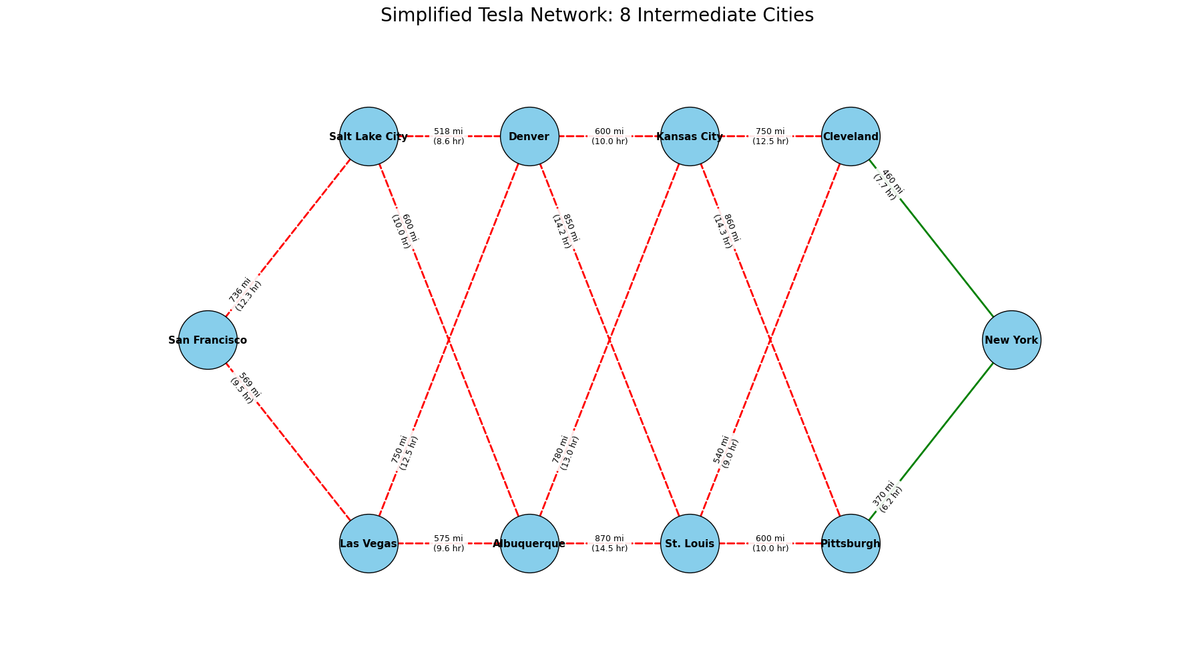

Figure 6a Simplified Tesla Network : 8 Intermediate Cities
The figure (fig. 6a) illustrates a simplified Tesla long-haul transportation network connecting San Francisco to New York through eight intermediate cities. Each node represents a major hub, while each edge denotes a feasible travel segment labeled with its corresponding distance in miles and estimated driving time in hours. The network is structured as two parallel eastbound corridors: an upper route through Salt Lake City, Denver, Kansas City, and Cleveland, and a lower route through Las Vegas, Albuquerque, St. Louis, and Pittsburgh with diagonal cross-links providing additional routing flexibility.

6.1 Optimal Solution and Minimum Cost
Optimal Objective Value: The minimal total driving time calculated by the model is 49.73 hours. This value represents the total time accumulated from the selected sequence of arcs in the optimal path.
6.2 Optimal Path Sequence
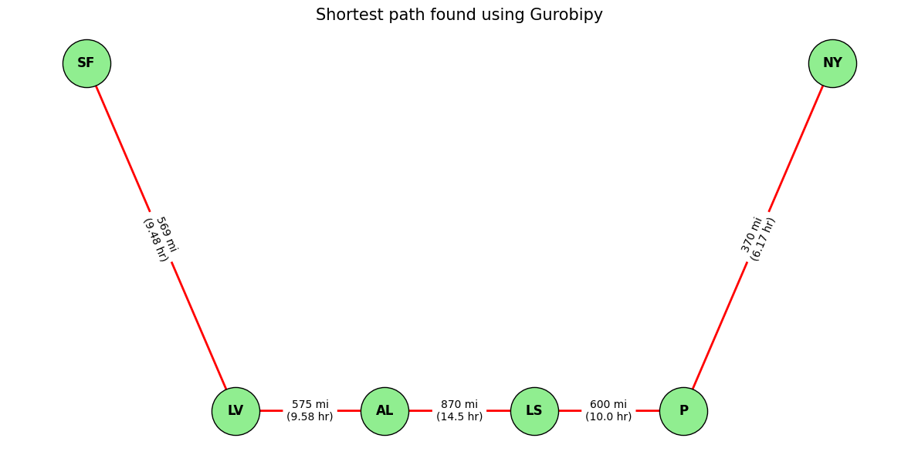
The optimal path sequence (fig. 6b) identified by the routing model consists of a five-segment journey connecting six major cities, meaning that out of all possible combinations in the network, the algorithm selects the single chain of city-to-city links that jointly produce the lowest cumulative travel time by prioritizing segments with shorter distances, reduced driving durations, and minimal charging penalties, thereby yielding the most time-efficient cross-country route from the origin to the final destination.
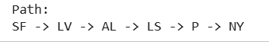

Figure 6b: Shortest Path found using Gurobi
7. Detailed Path Analysis & Insights
7.1 Path Composition: The optimal route consists of five major segments
- San Francisco → Las Vegas: 569 mi, 9.48 hr
- Las Vegas → Albuquerque: 575 mi, 9.58 hr
- Albuquerque → St. Louis: 870 mi, 14.50 hr
- St. Louis → Pittsburgh: 600 mi, 10.00 hr
- Pittsburgh → New York: 370 mi, 6.17 hr
7.1.1 Spatial Layout: The network was represented as a directed graph using fixed coordinate placements, creating a left-to-right progression from the starting point at (0, 2) to the final destination at (5, 2) and preserving the relative spatial arrangement of intermediate cities.
7.1.2 Visual Styling: High-contrast design elements were used, including light green nodes, red directional edges, and detailed edge labels displaying both distance in miles and driving time in hours, enhancing clarity and readability of the network visualization.The second part of the project focuses on the Minimum Total Cost route from San Francisco to New York .
7.1.3 Constraints Detail : The optimization was governed by three critical types of constraints
Flow Balance Constraints: Ensures a single, continuous path by requiring net flow ({flow out} -{flow in) to equal +1 at the origin SF ,-1 at the destination NY, and 0 at all intermediate cities.
Global Time Limit Constraint: The sum of all segment travel times for the entire route must not exceed the strict maximum trip duration of 80 hours.
Individual Driver Time Constraint: The cumulative driving time assigned to any single driver category (e.g., $A_{professional}$,$A_{amateur}$ and $B_{amateur}$,$B_{professional}$ ) must not exceed 18 hours, accounting for shift limits and fatigue rules.

7.2 Optimal Solution Summary
The Gurobi Optimizer identified the lowest-cost route that satisfies all model constraints, yielding an optimal total cost of $5,104.38 with a total trip time of 55.41 hours, well within the 80-hour limit. The solution achieved a 0.00 gap, confirming that the result is a guaranteed global optimum. The most constrained resource in the model was the B _{Professional} , who was utilized for 14.50 hours, remaining safely below the 18-hour maximum allowed.
7.3.Detailed Optimal Path Breakdown
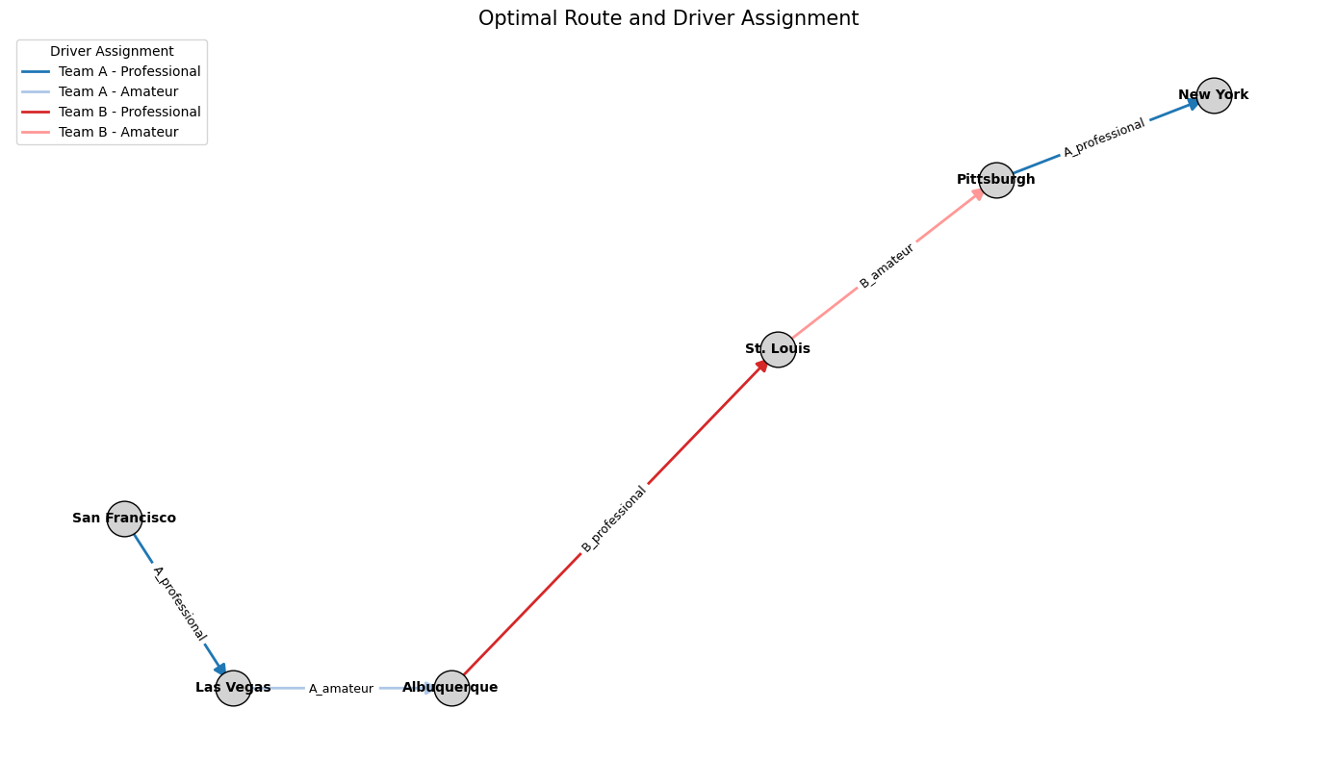
The cost minimization strategy involved strategically swapping between the two teams and driver types for different segments based on local costs and time penalties
Figure 7a : Optimal Route and Driver Assignment
8. Recommendations, Conclusions & Future Work
The analysis (fig.7a) shows that the shortest path from San Francisco to New York remains the most efficient route once cost, energy, and operational constraints are considered. Team A Professional drivers offer the lowest overall cost due to their higher effective speeds and lower wage rates, making them best suited for western segments such as San Francisco → Salt Lake City → Las Vegas → Denver → Albuquerque, while Team B drivers may still provide value on eastern segments like Kansas City → Cleveland → Pittsburgh → New York, where familiarity-based speed gains help maintain travel times without violating labor limits. Driver hour restrictions continue to be one of the most binding constraints, emphasizing that labor allocation is as important as route selection, and future improvements should incorporate more realistic operational factors such as charging behavior, partial or variable-speed charging, traffic and weather uncertainty, maintenance costs, and potential driver or route changes. Broadening the network to include additional cities and alternative paths would further strengthen the model’s robustness for real-world logistics planning.
9. Appendix
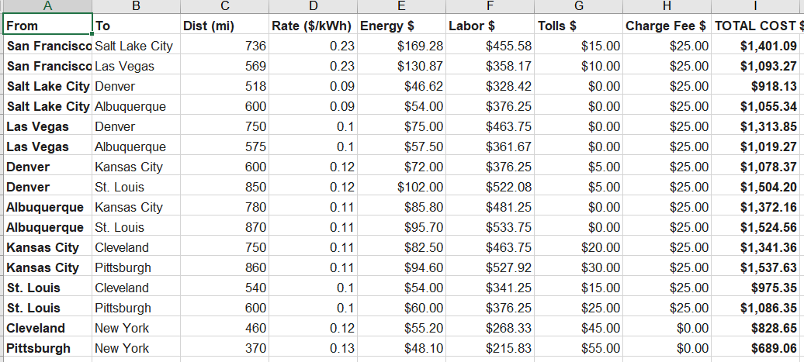
9.1 Mock data: This data (fig. A1) on segment costs and distances serves as the quantitative foundation for the entire logistics optimization process. By providing granular values for every variable, the optimization model is able to move beyond mileage or time calculations to perform a complex cost-benefit analysis, enabling the model to dynamically calculate the true economic impact of choosing a specific road segment and a specific driver team for that segment.
Figure A1. Mock Data (MockData.xlsx)

9.2 Driving Time per Driver
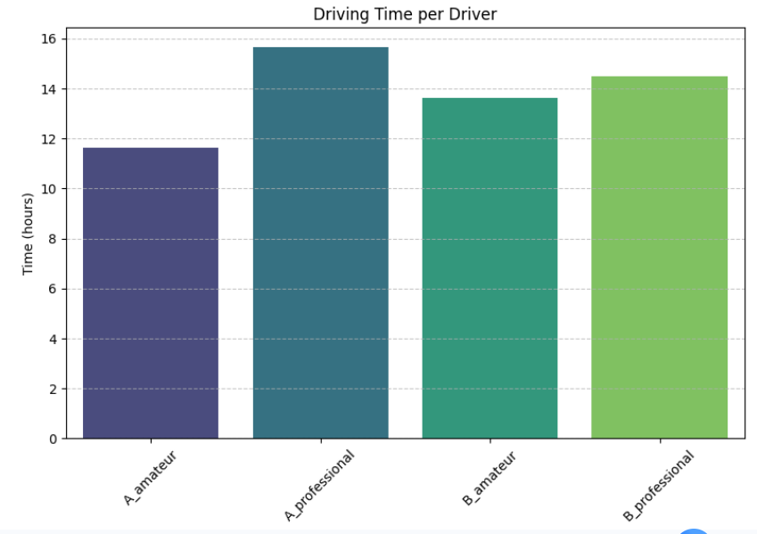

Figure A2 : Driving Time Per Driver
This graph (fig. A2) shows the total driving time in hours for each driver type.
- $A_{amateur}$: Drove for approximately 11.5 hours.
- $A_{professional}$: Drove for approximately 15.8 hours.
- $B_{amateur}$: Drove for approximately 13.7 hours.
- $B_{professional}$: Drove for approximately 14.5 hours.
Key Insights on Driving Time:
- Professionals Drive Longer (Overall): Both professional drivers drove longer hours than their amateur counterparts in their respective groups (A and B).
- Maximum Time: The $A_{professional}$ logged the maximum driving time (almost 16 hours).
- Minimum Time: The $A_{amateur}$ logged the minimum driving time (about 11.5 hours).
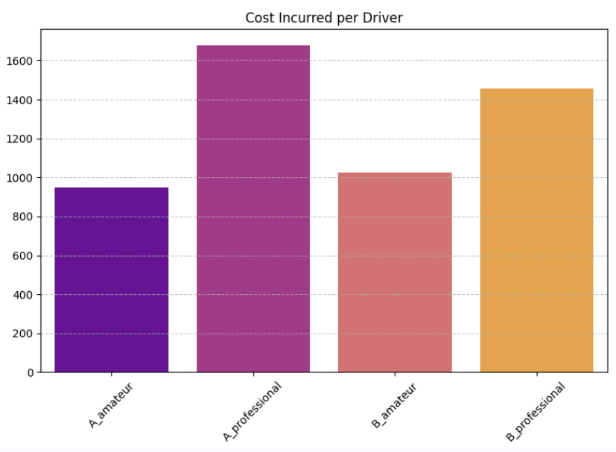
9.3 Cost Incurred per Driver

Figure A3: Cost Incurred per Driver
This graph (fig. A3) shows the total cost incurred (in dollars) for each driver type.
- A_{amateur}: Incurred a cost of approximately $950.
- A_{professional}: Incurred a cost of approximately $1,670.
- B_{amateur}: Incurred a cost of approximately $1,020.
- B_{professional}: Incurred a cost of approximately $1,450.

9.4 Key Insights on Cost:
- Professionals Cost More: Similar to driving time, professional drivers incurred significantly higher costs than the amateur drivers in both groups.
- Maximum Cost: The A_{professional} incurred the highest cost (over $1,600).
- Lowest Cost: The A_{amateur} incurred the lowest cost (under $1,000).
9.5 Combined Insights
Strong Correlation Between Time and Cost: In all four cases, a higher driving time directly corresponds to a higher incurred cost. This is a logical relationship, suggesting that cost is heavily influenced by the amount of time the driver is active, possibly due to factors like fuel, maintenance, or higher professional wages.

